**Coursework 2: Searching (50 marks)**

Consider the search space below, where *S* is the start node and *G1* and *G2* satisfy the goal test. Arcs are labeled with the cost of traversing them and the estimated cost to a goal (i.e., the *h* function) is reported inside nodes (so lower scores are better).

For each of the following search strategies, the goal state reached (G1 or G2) are all given in the tables.

(a)  **Breadth First**

(b)  **Depth First**

(c)  **Iterative Deepening**

(d)  **Uniform Cost (i.e., using f = g)**

(e)  **Best-First (using f = h)**

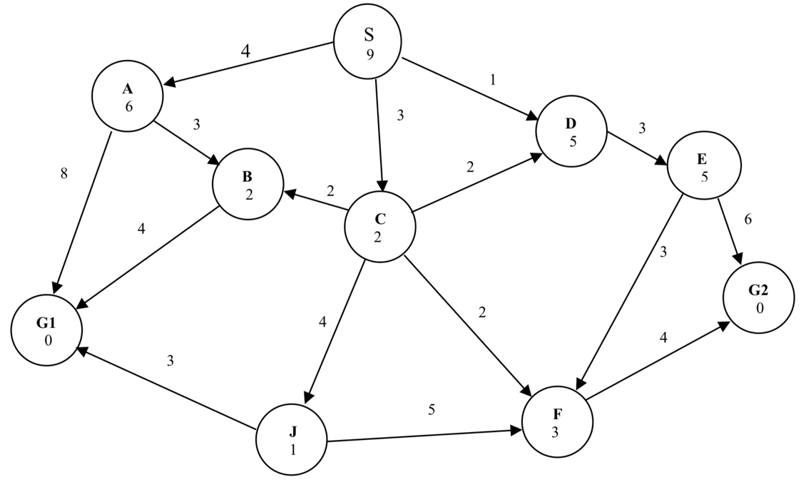

**Main Task**

1. Understand the table below for all search strategies (2a and 2b is for your basic understanding).
2. Using only (2c-2e), that is
   1. Iterative Deepening
   2. Uniform Cost (i.e., using f = g)
   3. Best-First (using f = h)

Perform the following

1. Implement a code that searches using 2c-2e in any programming language of choice. Use the tables below as a guide for the output.
2. Present your findings from your code, analysis, problems faced in the next three weeks. Design a powerpoint presentation for this and be ready to also show your code implementation.

Marking criteria

1. Correct code output based on tables shown (20).
2. Evidence of group work in presentation (10).
3. Accurate analysis showing deep understanding of each strategy used. Analysis can be based on preference of strategy, cost efficiency of one over another, ease of implementation, completeness etc (20).

COS5022-B: Coursework implementation of searching strategies

**2a. Breadth-first search**

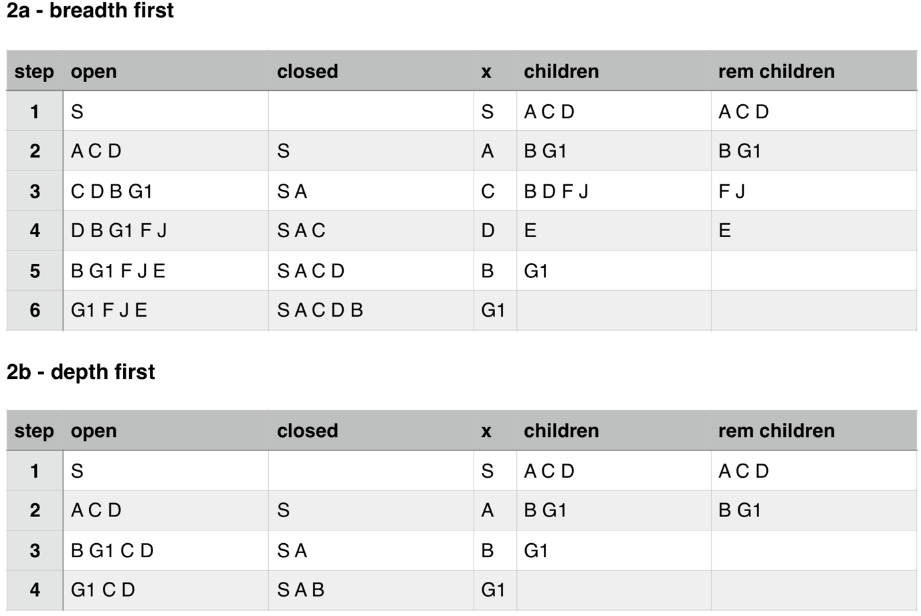

**2b. Depth first search**



